Level 0 -> Level 1

The goal of this level is to get the password of next level which is stored in the **readme** file which is in the **home** directory.

So now, firstly we will check the files and folders of the current directory in which we are by using **ls** command. Simple **ls** command is used to list out all the files and folder of the directory in which the user is present.

When we run **ls** command it will list the name of file **readme**. It means that we are already in **home** directory and the required file is present.

We can read the content of the file using **cat** command. The file contains the password for level 1.

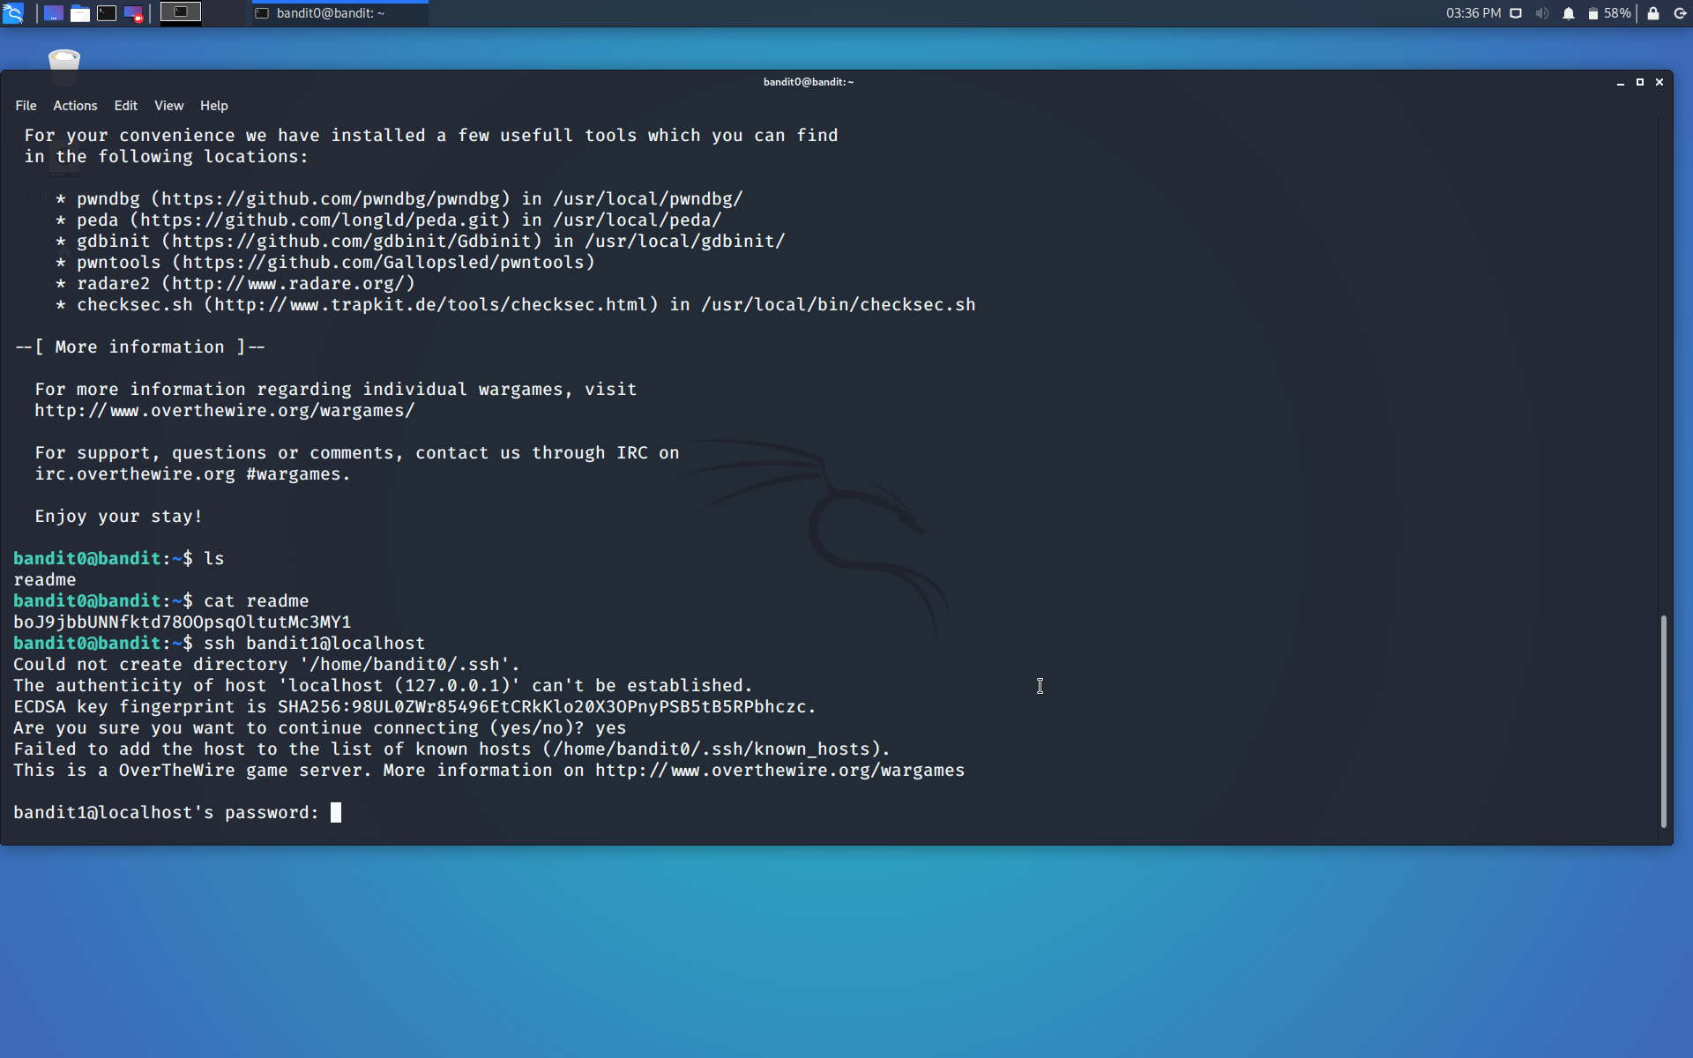

Use the command **ssh bandit1@localhost** to connect to the level 1.

Enter the password and hit enter.

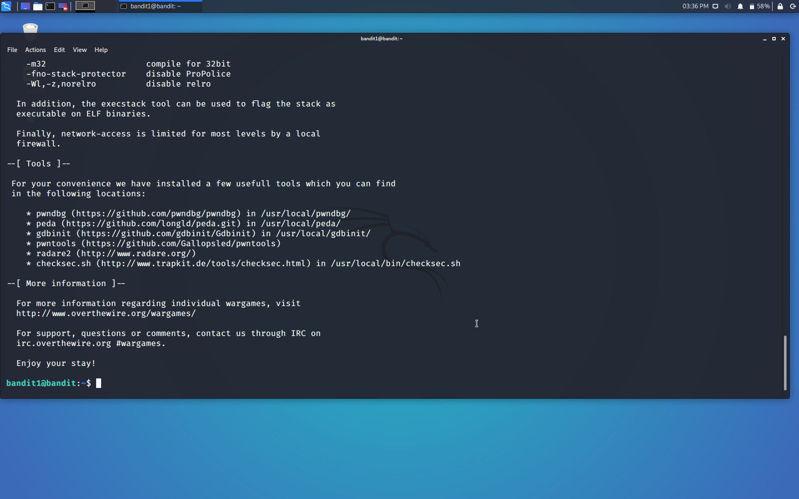

Successfully passed level1.…